URL | Screenshot for studentadventuretours
http://www.10best.com/awards/new-media-awards/best-business-travel-blogger/
http://athemes.com/collections/best-travel-wordpress-themes/#comment-775745 | 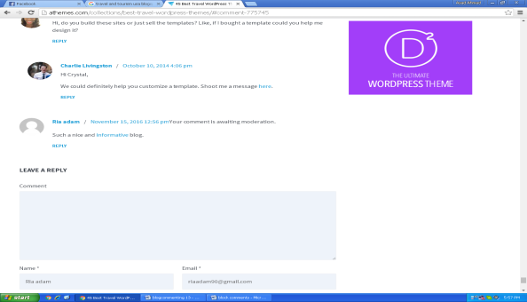
http://theblogabroad.com/2015/09/15/why-more-black-people-need-to-travel-around-europe/ | 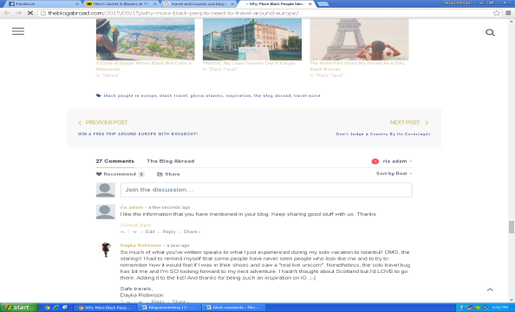
http://www.flightnetwork.com/blog/top-100-canadian-travel-blogs/#comment-132003 | 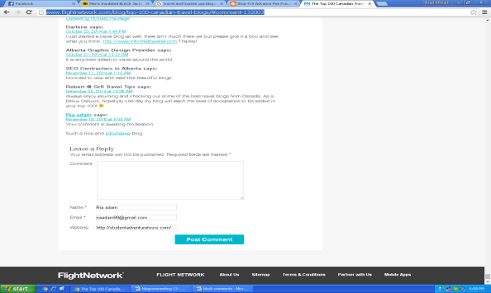
http://419advancefeefraud.blogspot.com/2016/11/dubenskaya-tankfarmru-russian-oil-scam.html#comment-form | 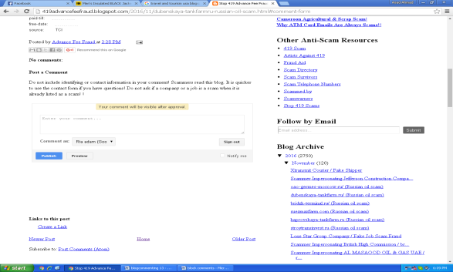
https://tourism-travel-eco-adventure.blogspot.com/2016/09/blog-post.html?showComment=1479215567577#c374829525774568402 | 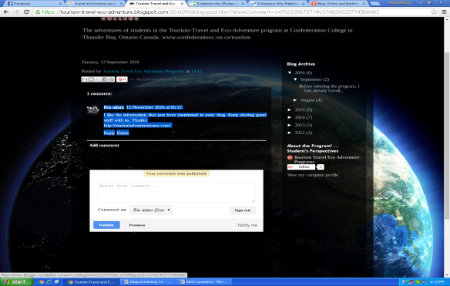
https://www.statravel.co.uk/travel-blog/2013/04/6-reasons-why-malaysia-is-the-ultimate-travel-destination/ | 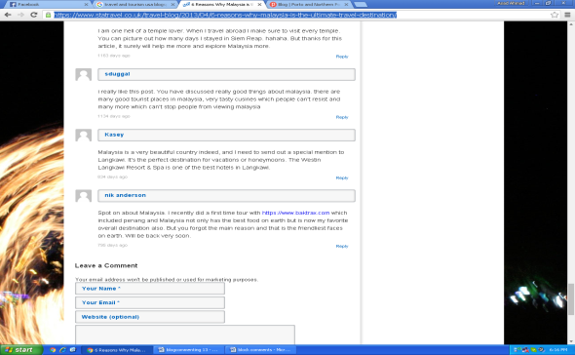
http://girlvsglobe.com/2014/06/50-travel-blog-post-ideas.html | 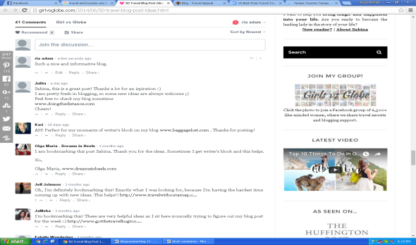
http://www.beautifullife.info/web-design/15-best-free-travel-templates/comment-page-1/#comment-658681 | 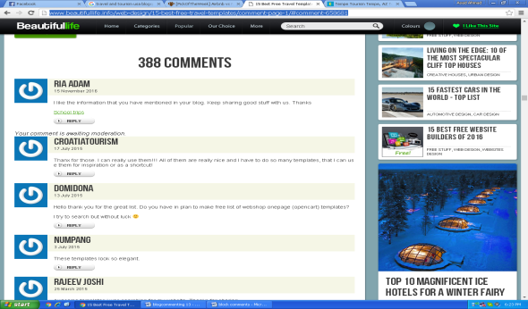
http://blog.nheconomy.com/meaningful-match-signup-today-for-the-nh-small-business-matchmaker/#comment-1390416 | 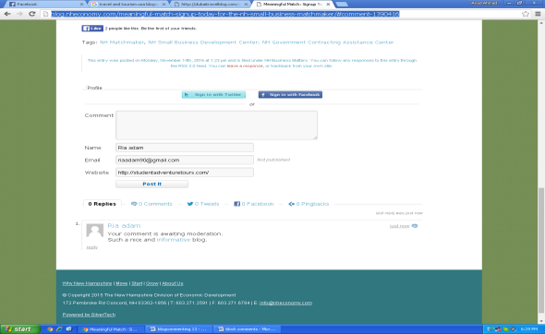
http://travelandtourworld.blogspot.com/2016/11/la-manga-club-dishes-up-worldwide-treat.html#comment-form | 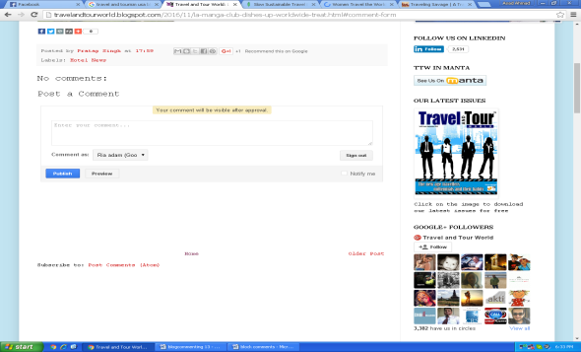
http://charlieontravel.com/best-budget-airbnbs-mexico/#comment-60719 | 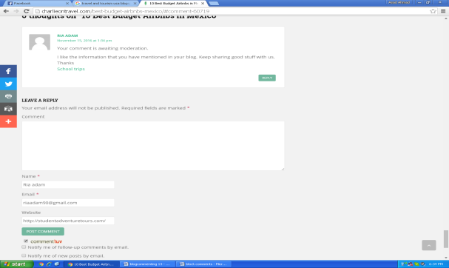
http://www.bobaroundtheworld.com/top-100-travel-blogs-2015/#comment-8737 | 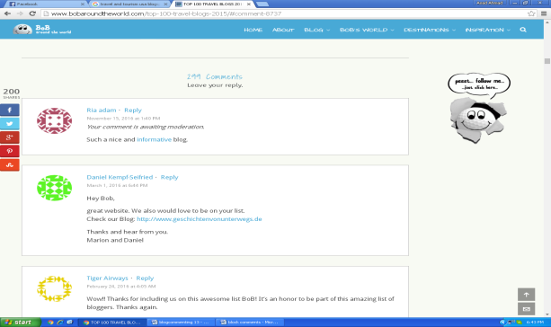
http://www.shareable.net/blog/the-ultimate-guide-to-traveling-without-money | 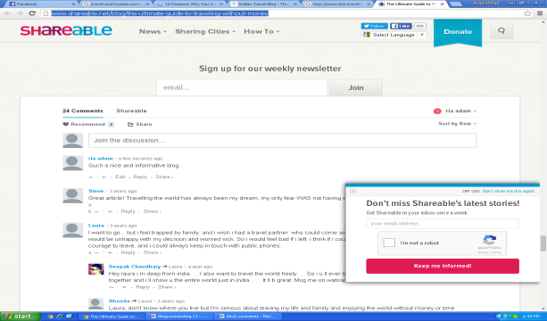
http://www.sidetrackedtravelblog.com/blog/2015/7/20/10-reasons-why-you-should-visit-vancouver | 